|  |  |  |  |
| --- | --- | --- | --- |
| 1 | | 3,000.0 | |
| NUMERO DE FRONTERAS | | ENERGIA AGREGADA | |
|  | | | |
| NO | | 0 | |
| CONTRATO | | VENCIMIENTO CONTRATO | |
|  | | | |
| 8,561,256 | 77 | | 331,809 |
| INGRESO 2019 | DÍAS CERTIFICADOS 2019 | | ENERGIA RESPALDADA 2019 |
|  | | | |
| 20,366,585 | 77 | | 809,136 |
| INGRESO 2020 | DÍAS CERTIFICADOS 2020 | | ENERGIA RESPALDADA 2020 |
|  | | | |
| 200,924 | 3 | | 9,000 |
| INGRESO 2021 | DÍAS CERTIFICADOS 2021 | | ENERGIA RESPALDADA 2021 |

|  |
| --- |
| **HAMPTON CARTAGENA**  USUARIO |

|  |
| --- |
| **Mateo Porras**  Ejecutivo de cuenta |

|  |
| --- |
| **Julian Avila / Director de Gestión de Activos / javila@metro-op.com**  Primera fecha: PUNTO FOCAL |

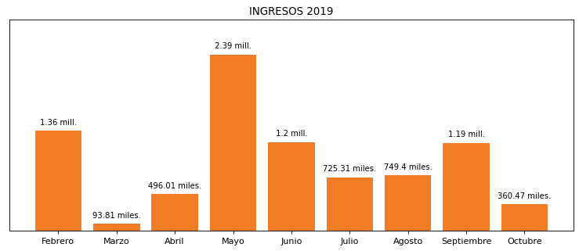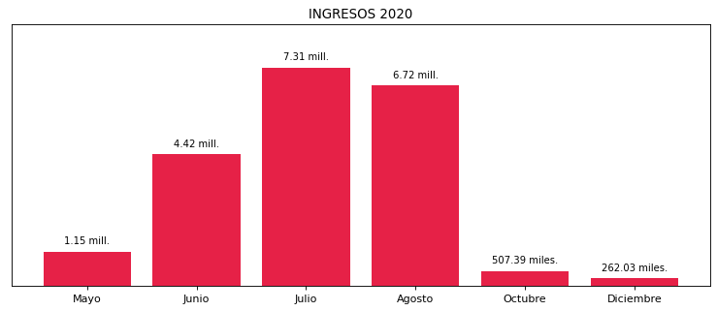

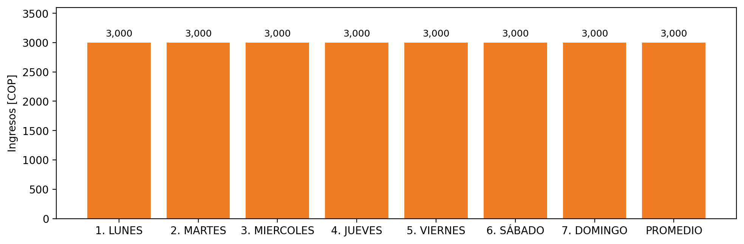

|  |  |  |  |  |  |  |  |  |  |
| --- | --- | --- | --- | --- | --- | --- | --- | --- | --- |
| **FRONTERA COMERCIAL** | **TIPO DDV** | **COD SIC** | **PREDIO** | **PROMEDIO** | **MARGEN** | **ÚLTIMA DESCONEXION** | **DÍAS CERTIFICADOS** | **ACTUALIZACION** | **PROXIMA PRUEBA DDV** |
| HOTEL HAMPTON CARTAGENA | Frt37946 | Frt20425 | Prd02037 | 3,000 | NO APLICA | 2020-05-08 | 80.0 | 2023-04-15 | 2021-11-30 |